DAY- 32 (3/9/2025) & 33(4/9/2025)
Emp ID : 110714877
NAME :Kinnera venkatamma

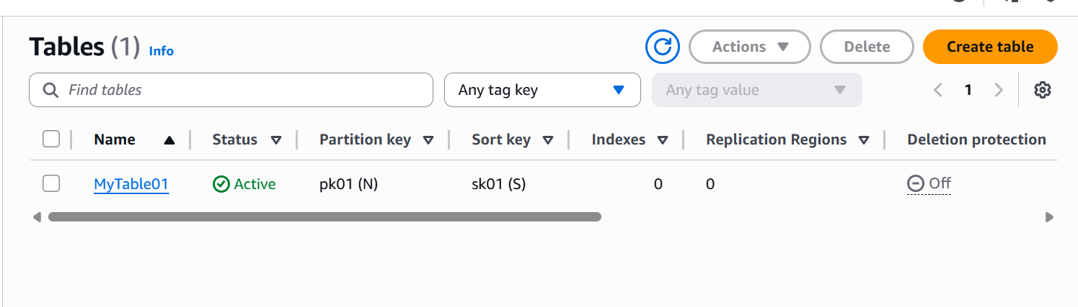

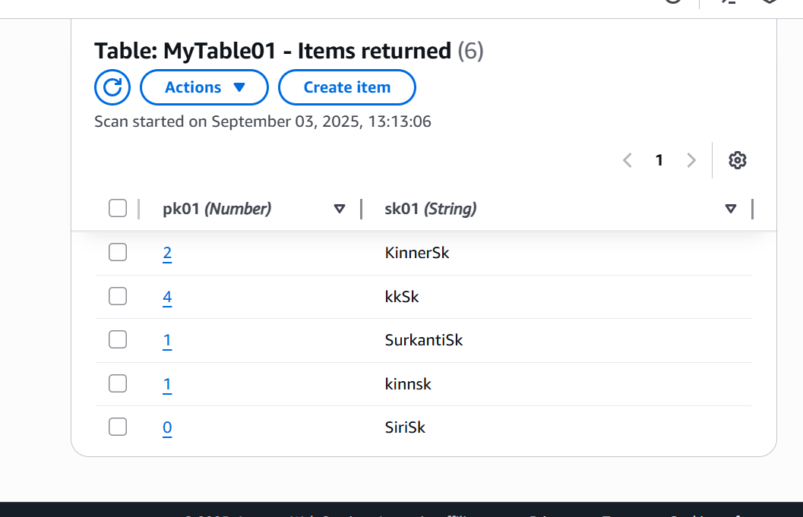
Table creation -Doing CRUD operations using CLI(command line interface)
aws dynamodb create-table --table-name Employee --attribute-definitions AttributeName=ID,AttributeType=N attributeName=EmpName,AttributeType=S --key-schema AttributeName=ID,KeyType=HASH AttributeName=EmpName,KeyType=RANGE --provisioned-throughput ReadCapacityUnits=5,WriteCapacityUnits=5

aws dynamodb put-item --table-name Employee --item '{"ID": {"N": "1001"},"EmpName": {"S": "Prasunamba"}}'

aws dynamodb put-item --table-name Employee --item '{"ID": {"N": "1002"},"EmpName": {"S": "Meher"} }'
aws dynamodb query --table-name Employee01 --key-condition-expression "ID = :ID" --expression-attribute-values '{":ID":{"N":"1001"}}'

aws dynamodb update-item --table-name Employee01 --key '{"ID": {"N": "1001"} , "EmpName": {"S": "Prasunamba"} }' --update-expression "set info = :info" --expression-attribute-values '{":info": {"S": "MK"}}'

aws dynamodb delete-item --table-name Employee --key '{"ID": {"N": "1001"}, "EmpName":{"S": "Prasunamba"} }'
aws dynamodb list-tables
-to check complete tables
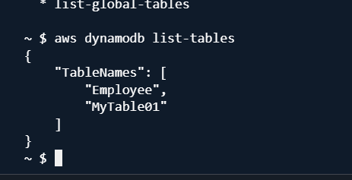

--detailed info about our table
aws dynamodb describe-table --table-name Employee
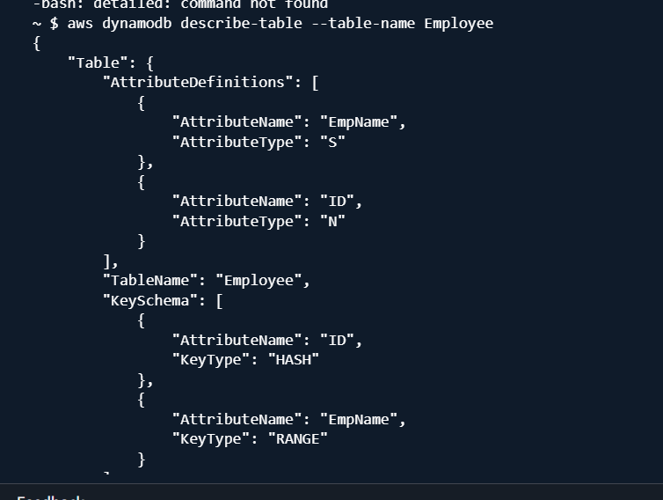

For installation:
Install aws cli
Aws version:
aws --version

--to scan table
aws dynamodb scan --table-name Employee
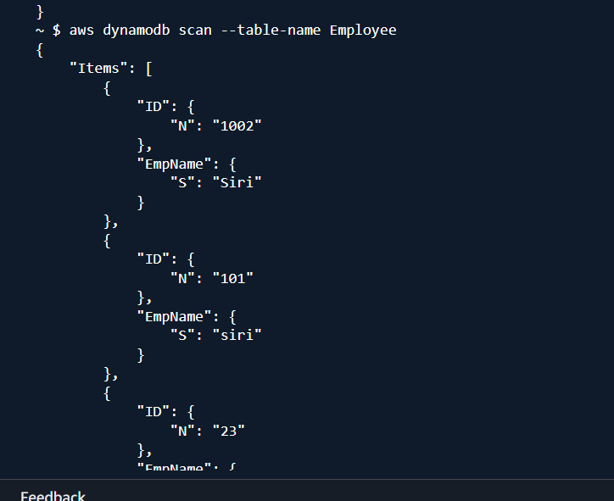

-Other way of creating table
aws dynamodb wizard new-table
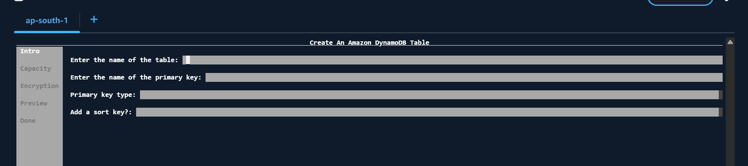

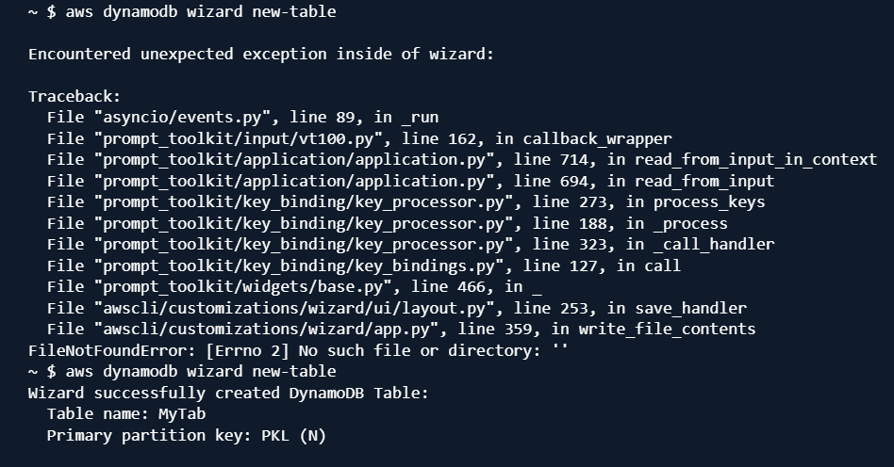

--taking backup of a table
aws dynamodb create-backup
--table-name Employee01
--backup-name MyEmployee01backup

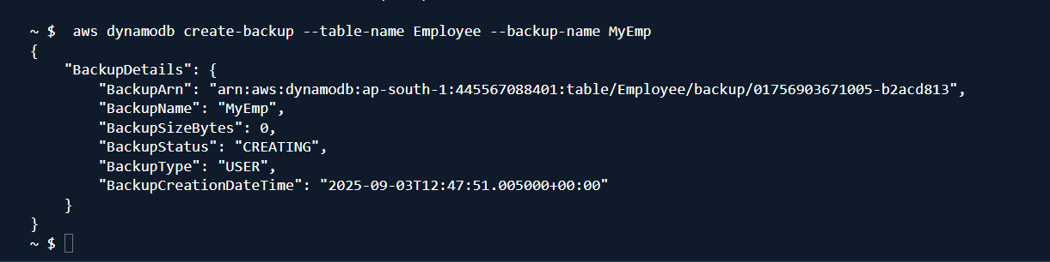

Creating a table

aws dynamodb create-table --table-name Employee --attribute-definitions AttributeName=ID,AttributeType=N attributeName=EmpName,AttributeType=S --key-schema AttributeName=ID,KeyType=HASH AttributeName=EmpName,KeyType=RANGE --provisioned-throughput ReadCapacityUnits=5,WriteCapacityUnits=5

insert into table

aws dynamodb put-item --table-name Employee01 --item '{"ID": {"N": "1001"},"EmpName": {"S": "Prasunamba"}}'

aws dynamodb put-item --table-name Employee01 --item '{"ID": {"N": "1002"},"EmpName": {"S": "Meher"} }'
.....

Query:

aws dynamodb query --table-name Employee01 --key-condition-expression "ID = :ID" --expression-attribute-values '{":ID":{"N":"1001"}}'

Update:

aws dynamodb update-item --table-name Employee01 --key '{"ID": {"N": "1001"} , "EmpName": {"S": "Prasunamba"} }' --update-expression "set info = :info" --expression-attribute-values '{":info": {"S": "MK"}}'

Delete :

aws dynamodb delete-item --table-name Employee01 --key '{"ID": {"N": "1001"}, "EmpName":{"S": "Prasunamba"} }'

—------------------------------------------------------------------------------------------------------------------

DAY-33

Task 01: What do you understand by DynamoDb Architecture.. ? explain using a diagram.

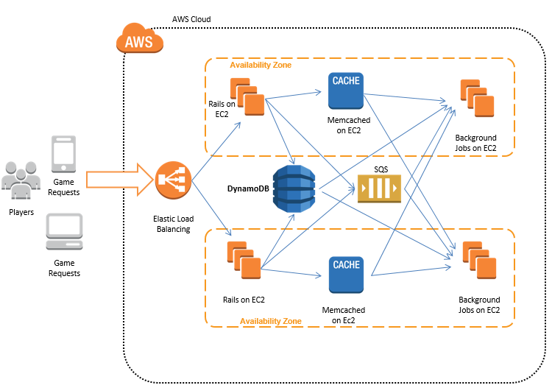

Task 02: What are multivalue sorts or filters..? Explain briefly..

Multivalue sorts and filters operate on fields containing multiple values for a single record, such as a list of tags or product categories. A multivalue filter selects records where at least one value in the field matches the filter criterion, while a multivalue sort arranges these multiple values within the field in a specific order, like alphabetical or numerical.
How they work
Multivalue Fields:
These fields hold several distinct pieces of information within a single field, often separated by delimiters like commas. For example, a "Tags" field might contain "database; milestone1" for one record and "performance; database" for another.
Multivalue Filters:
When you filter on a multivalue field, the filter applies to each individual value within the field. For instance, if you filter for "database" in a list of tags, any record with "database" in its tags will be included.
Multivalue Sorts:
These operations reorder the values within a multivalue field according to a defined rule, like sorting the tags alphabetically or numbers from smallest to largest.
Examples
Filtering:
In a CRM system, a customer might have multiple "Interests" such as "Marketing," "Sales," and "Tech". If you filter for "Marketing," only records with "Marketing" in their interests list will be displayed.
Sorting:
A list of product categories for a single product could be "Electronics, Home Goods, Apparel". A multivalue sort could change this to "Apparel, Electronics, Home Goods".

Task 03: How do you lower the cost of DynamoDB. explain ways to do so…

How to Reduce DynamoDB Costs
- Watch Item Sizes. ...
- Limit Secondary Indexes. ...
- Use Transactions Sparingly. ...
- Be Selective with Global Tables. ...
- Consider Eventually Consistent Reads. ...
- Choose the Right Billing Mode. ...
- Review Table Storage Classes Monthly. ...
- “DynamoDB pricing should influence how you build your application
To lower DynamoDB costs, choose the correct table class and capacity mode (On-Demand for
unpredictable workloads or Provisioned with auto-scaling for predictable ones), optimize data models
by storing large objects in Amazon S3, using short attribute names, and enabling Time to Live (TTL) for
automatic data deletion. Also, regularly monitor usage with AWS Cost Explorer, delete unused tables
and indexes, use batch operations, and favor queries over scans.
Optimize Capacity &amp; Billing..

Choose the Right Capacity Mode:
Use On-Demand capacity mode for unpredictable or intermittent workloads, as it automatically scales
throughput and you only pay for what you use. For predictable workloads, use Provisioned capacity
with auto-scaling to avoid over-provisioning.
Use Auto-Scaling:
For provisioned tables, enable auto-scaling to automatically adjust read/write capacity based on
actual usage, preventing you from paying for unused capacity.
Select Appropriate Table Class:
Use the Standard-IA table class for tables with data that is infrequently accessed to reduce storage
costs, but be mindful of higher read and write costs for this class.
Enable Time to Live (TTL):
Use the TTL feature to automatically delete expired items from your tables, which reduces storage
costs and helps keep tables clean.
Optimize Data Models
Store Large Objects Externally:
Move large objects like images or videos to Amazon S3 and store only the S3 object identifiers in
DynamoDB, significantly reducing storage costs.
Use Shorter Attribute Names:
Attribute names contribute to the item size, so using shorter names reduces overall storage costs.
Minimize Attributes:

Reduce the number of attributes per item to lower storage and data transfer costs.
Compress Data:
Compress large attribute values using algorithms like GZIP before storing them to reduce storage
costs.
Optimize Operations
Use Query Operations:
Favor Query operations over Scan operations, as Scans read all items in a table and can be expensive.
Use Batch Operations:
Group multiple write or read operations into a single batch request to reduce the number of API calls
and potentially lower costs, especially for high-frequency write applications.
Avoid Unnecessary Strong Reads:
Use strongly consistent read operations sparingly, as they consume more capacity units and are more
expensive than eventually consistent reads.
Monitor and Manage Resources
Delete Unused Resources:
Regularly identify and delete unused DynamoDB tables and secondary indexes to eliminate wasted
spending.
Monitor Costs with AWS Cost Explorer:
Use AWS Cost Explorer to analyze your DynamoDB spending, track usage patterns, and identify areas
for optimization.
Utilize Cost Allocation Tags:
Apply tags to your DynamoDB resources to better track costs by project, department, or application.

